PARTH ASHRA
ROLL NO.1
IT
EXPERIMENT NO.7

#include<stdio.h>
#include<stdlib.h>
int source,V,E,time,visited[20],G[20][20];
void DFS(int i)
{
int j;
visited[i]=1;
printf("%d->",i+1);
for(j=0;j<V;j++)
{
if(G[i][j]==i&&visited[j]==0)
DFS(j);
}
}
int main()
{
int i,j,v1,v2;
printf("\t\t\tGraphs\n");
printf("Enter the number of edges");
scanf("%d",&E);
printf("Enter the number of vertices");
scanf("%d",&V);
for(i=0;i<V;i++)
{
for(j=0;j<V;j++)
G[i][j]=0;
}
for(i=0;i<E;i++)
{
printf("Enter the number of edges(format: V1 V2):");
scanf("%d%d",&v1,&v2);
G[v1-1][v2-1]=1;
}
for(i=0;i<V;i++)
{
for(j=0;j<V;j++)
printf("%d",G[i][j]);
printf("\n");
}
printf("Enter the source:");
scanf("%d",&source);
DFS(source-1);
return 0;
}
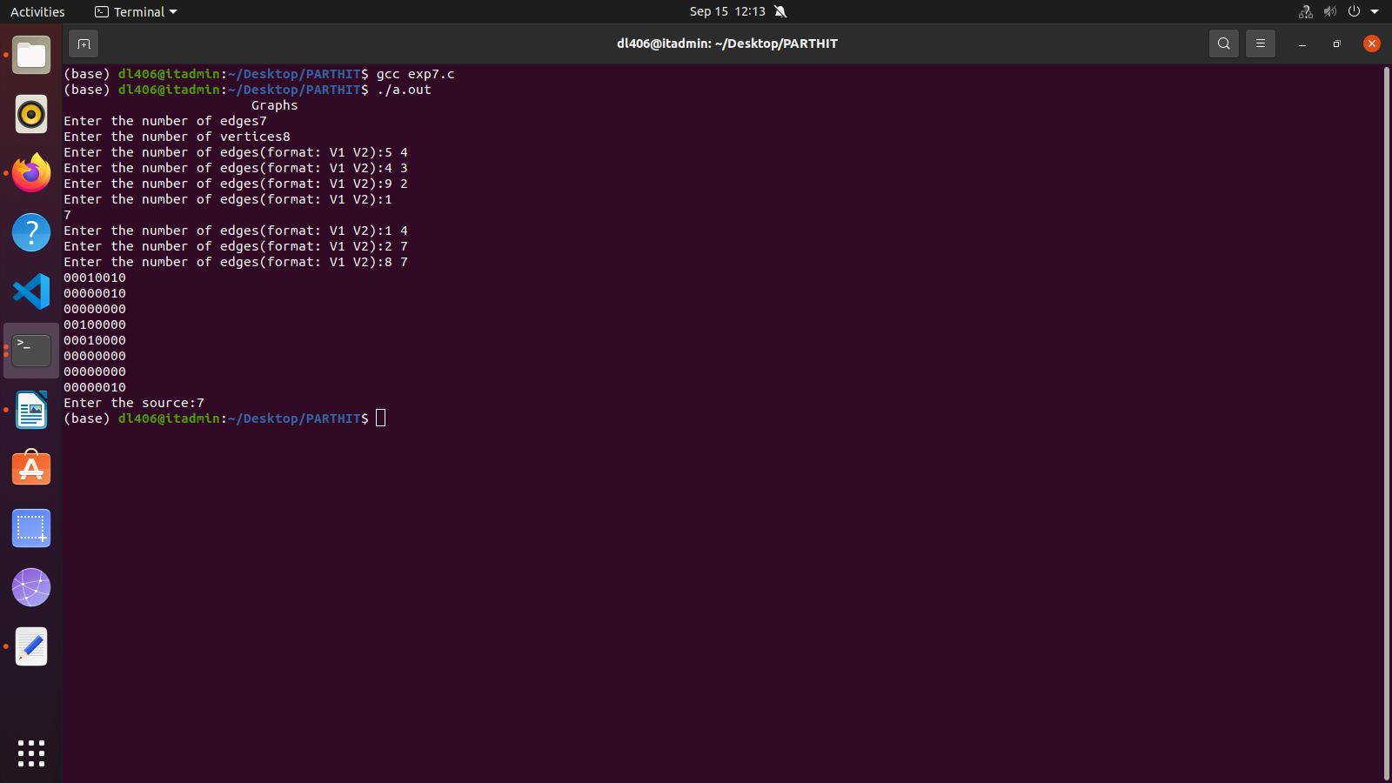
#include<stdio.h>
int a[20][20],q[20],visited[20],n,f=-1,r=-1;
void bfs(int v)
{
int i;
for(i=0;i<n;i++)
{
if(a[v][i] !=0 && visited[i]==0)
{
r=r+1;
q[r]=i;
visited[i]=1;
printf("%d",i);
}
}
f=f+1;
if(f<=r)
bfs(q[f]);
}
int main()
{
int v,i,j;
printf("\nEnter number of vertices");
scanf("%d",&n);
for(i=0;i<n;i++){
visited[i]=0;}
printf("\nEnter graph data in matric from\n");
for(i=0;i<n;i++)
for(j=0;j<n;j++)
scanf("%d",&a[i][j]);
printf("\nEnter the starting vertex");
scanf("%d",&v);
f=r=0;
q[r]=v;
visited[v]=1;
printf("%d",v);
bfs(v);
if(r!=n-1)
printf("\nBFS not possible");
printf("\n");
return 0;
}
